**PRACTICAL NO: 6**

**AIM: TO SOLVE THE QUERY USING THE CONCEPT OF VIEWS AND TRIGGERS**

**USE FYIT_40**

Q1. CREATE A VIEW SHOWING CUSTOMER NAME, ADDRESS AND CITY

CREATE VIEW V1 AS

SELECT cname,cadd,city

from CUSTOMER

SELECT * FROM V1

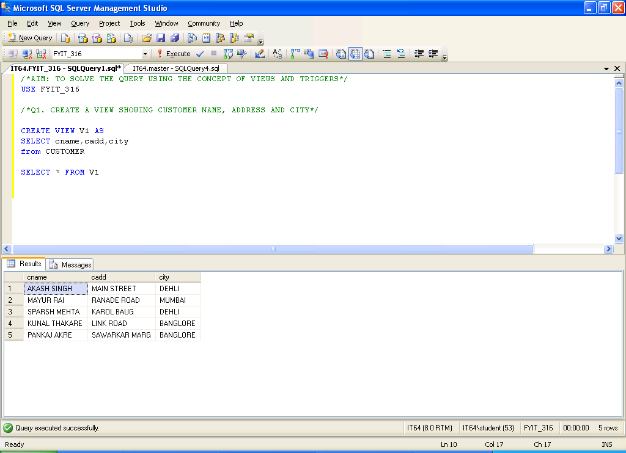

Q2. CREATE A VIEW SHOWING SALESMAN LIVING IN CITY MUMBAI

CREATE VIEW V2 AS

SELECT SNAME

FROM SALESMASTER

WHERE CITY='MUMBAI'

SELECT * FROM V2

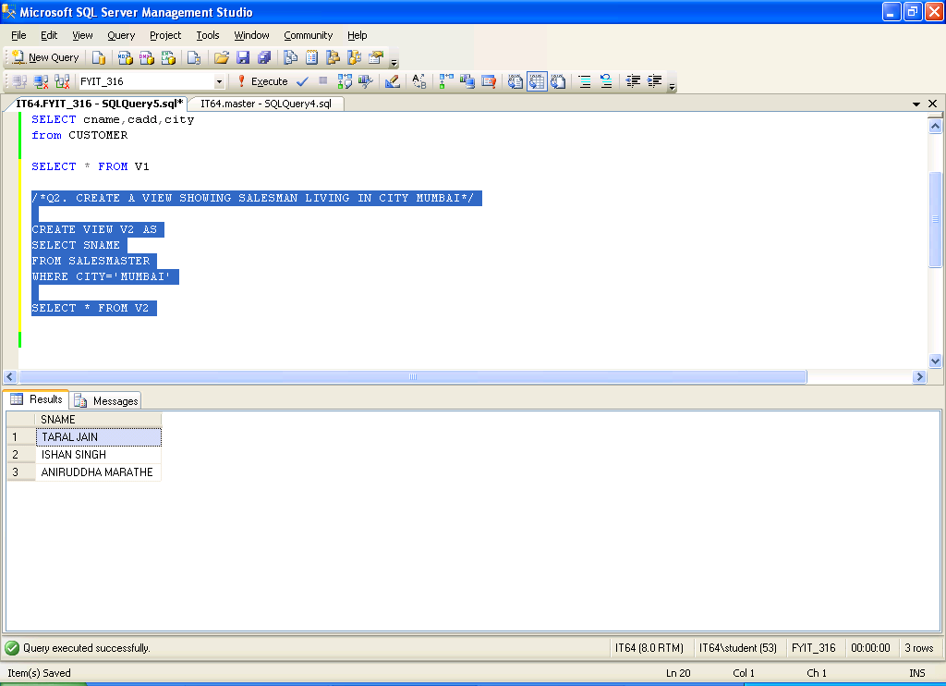

Q3. CREATE A VIEW SHOWING CUSTOMER DETAILS WITH THEIR ORDER DETAILS

CREATE VIEW V3(CUSTNAME,ONO,ODATE) AS

SELECT cname,ORDERNO,ORDERDT

FROM CUSTOMER C,SALESORDER SO

WHERE C.custno=SO.CUSTNO

SELECT * FROM V3

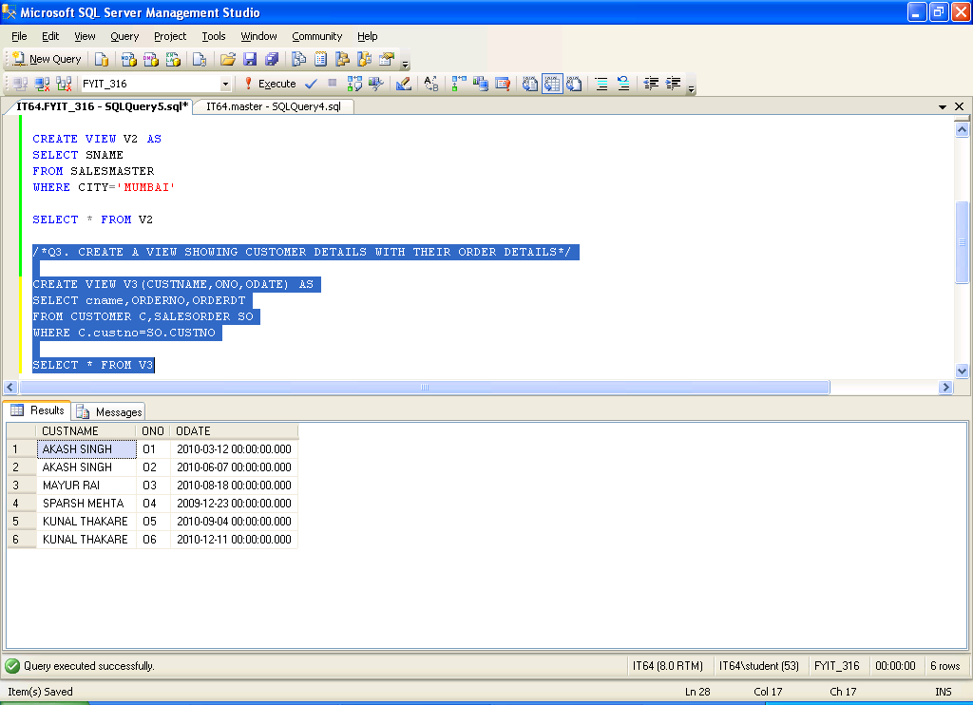

Q4. CREATE A VIEW SHOWING DETAILS OF CUSTOMER PLACING THE ORDER AND THE DETAILS OF SALESMAN TAKING THE ORDER

CREATE VIEW V4(CUSTNAME,SALEMANNAME,ONO,ODATE) AS

SELECT cname,SNAME,ORDERNO,ORDERDT

FROM CUSTOMER C,SALESORDER SO,SALESMASTER SM

WHERE C.custno=SO.CUSTNO AND

SO.SALESMANNO=SM.SALESMANNO

SELECT * FROM V4

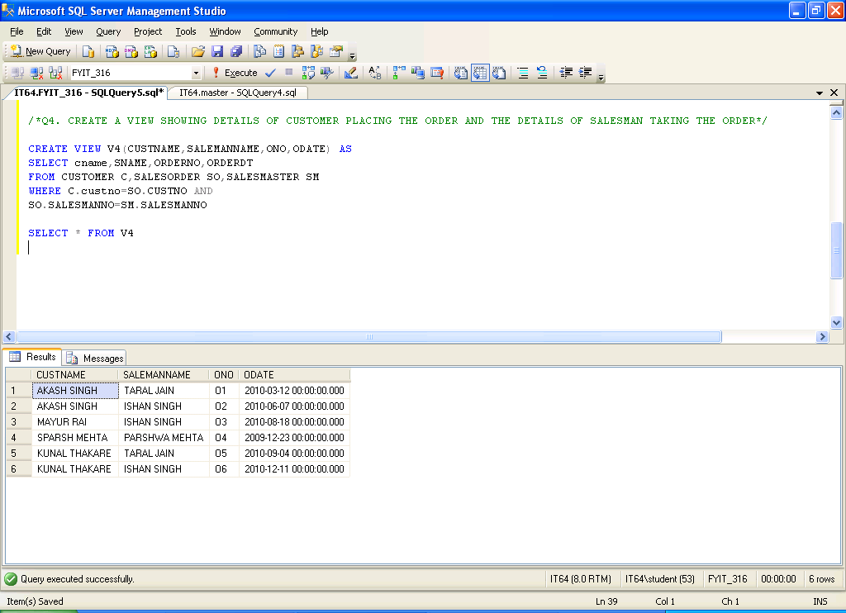

Q5. CREATE A VIEW SHOWING TOTAL NO. OF CUSTOMERS LIVING IN EACH CITY

CREATE VIEW V5(TOTAL,CITY) AS

SELECT COUNT(CUSTNO),CITY

FROM CUSTOMER

GROUP BY CITY

SELECT * FROM V5

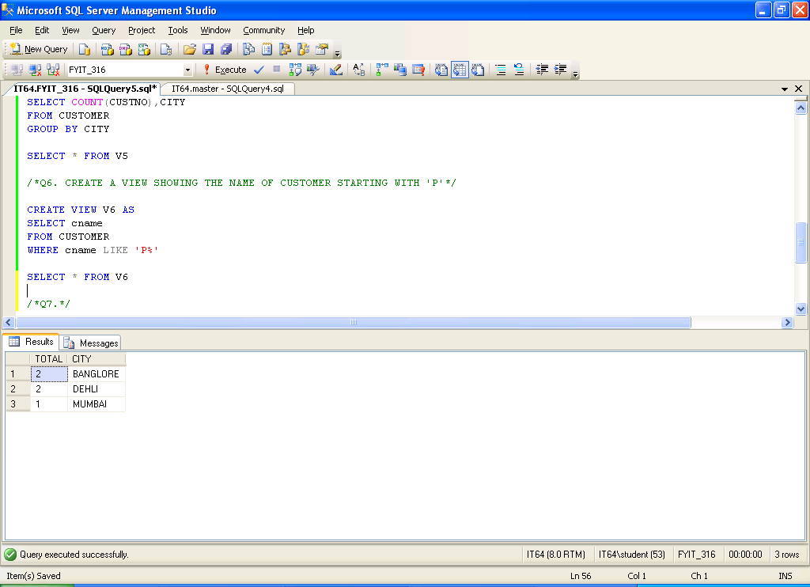

Q6. CREATE A VIEW SHOWING THE NAME OF CUSTOMER STARTING WITH 'P'

CREATE VIEW V6 AS

SELECT cname

FROM CUSTOMER

WHERE cname LIKE 'P%'

SELECT * FROM V6

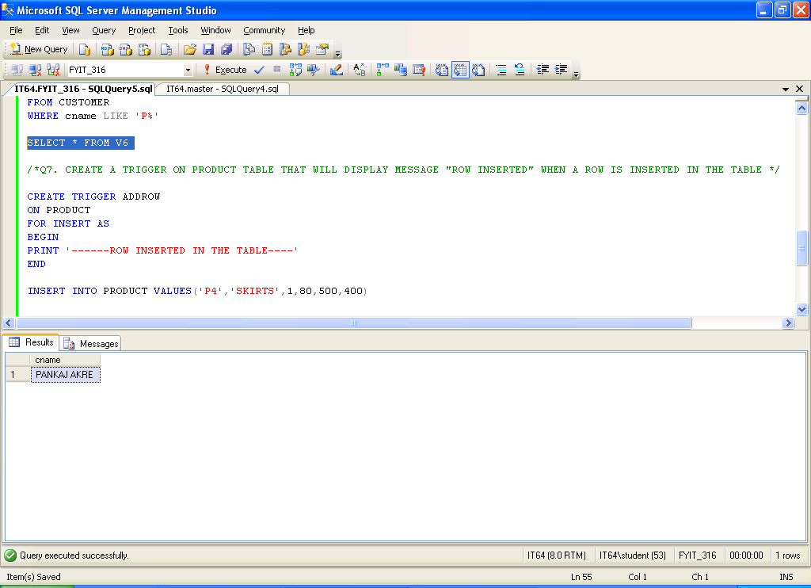

Q7. CREATE A TRIGGER ON PRODUCT TABLE THAT WILL DISPLAY MESSAGE "ROW INSERTED" WHEN A ROW IS INSERTED IN THE TABLE

CREATE TRIGGER ADDROW

ON PRODUCT

FOR INSERT AS

BEGIN

PRINT '------ROW INSERTED IN THE TABLE----'

END

INSERT INTO PRODUCT VALUES('P4','SKIRTS',1,80,500,400)

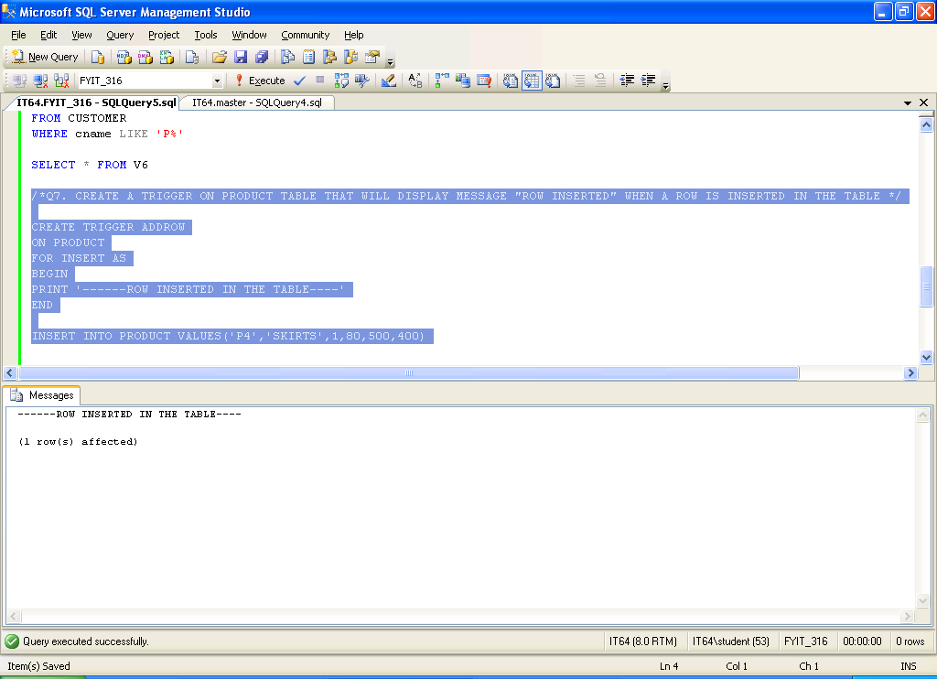

SELECT * FROM PRODUCT

